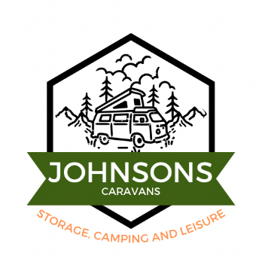

**Privacy Policy for Johnsons Caravans**

*Last updated: 16/10/2024*

**1. Introduction**

Johnsons Carvans ("we," "us," or "our") respects your privacy and is committed to protecting the personal information you share with us. This Privacy Policy explains how we collect, use, and safeguard your information when you use our services.

**2. Information We Collect**

We may collect the following types of information from you:

* **Personal Information:** Name, address, phone number, email address, and payment information.
* **Identification Information:** Driver's license or other identification documents for security and verification purposes.
* **Vehicle Information:** Details about the caravan, including make, model, registration number, and storage preferences.
* **Usage Information:** Information related to the use of our website, such as cookies and log data.

**3. How We Use Your Information**

We may use your information for the following purposes:

* To provide and manage storage services.
* To communicate with you about your storage arrangement, billing, and other services.
* To ensure the security and safety of our storage facilities.
* To comply with legal and regulatory requirements.

**4. How We Share Your Information**

We do not sell or share your personal information with third parties, except in the following situations:

* With service providers who assist us in operating our business (e.g., payment processors, IT services) and are bound by confidentiality obligations.
* When required by law or to comply with legal processes.
* To protect our rights, property, or safety and that of our customers or others.

**5. Data Security**

We take reasonable steps to protect the information you provide from unauthorized access, disclosure, alteration, or destruction. However, no data transmission over the internet or electronic storage is 100% secure.

**6. Retention of Information**

We retain your personal information only as long as necessary for the purposes outlined in this policy or as required by law.

**7. Your Rights**

You have the right to:

* Access the personal information we hold about you.
* Request corrections to inaccurate or incomplete information.
* Request the deletion of your personal information, subject to certain conditions.
* Opt-out of marketing communications.

To exercise these rights, please contact us at [Your Contact Information].

**8. Changes to This Privacy Policy**

We may update this Privacy Policy from time to time to reflect changes in our practices or for legal or regulatory reasons. We will notify you of any changes by posting the new policy on our website.

**9. Contact Us**

If you have any questions or concerns about this Privacy Policy or our data practices, please contact us at:

Johnsons Caravans

Tenison Vale, shortthorn Road, Stratton Strawless, Norwich, NR10 5NU

07808714403

Johnsons_caravans@outlook.com